Testing RV M1 Robot (Stand Alone)

- Turn the Robot on at the power switch located at the rear of the Robot Drive Unit
- Check that the Robot Teach Pendant ON/Off switch is in the ON position.
- Nest the Robot. To do this
Press the NST button on the Teach Pendant
Press the ENT button on the Teach Pendant
The robot will move to its Nest (park) position
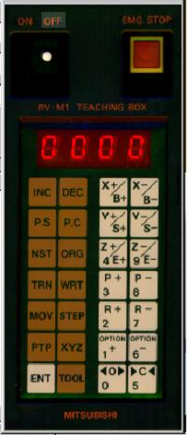
Confirm Robot moves to its Nest position | Pass / Fail

- Press and hold the X-/B- button until the BASE axis begins to rotate.
- Release the X-/B- button
Confirm the BASE axis rotates | Pass / Fail
- Press and hold the Y+/S+ button until the SHOULDER axis begins to rotate.
- Release the Y+/S+ button
Confirm the SHOULDER axis rotates | Pass / Fail
- Press and hold the Z+/E+ button until the ELBOW axis begins to rotate.
- Release the Z+/E+ button
Confirm the Elbow axis rotates | Pass / Fail
- Press and hold the P+ button until the PITCH axis begins to rotate.
- Release the P+ button
Confirm the PITCH axis rotates | Pass / Fail
- Press and hold the R- button until the ROLL axis begins to rotate.
- Release the R- button
Confirm the ROLL axis rotates | Pass / Fail
- Press the ‘C’ button.
- The Gripper Fingers CLOSE
Confirm the Gripper Fingers CLOSE | Pass / Fail
- Press the ‘O’ button.
- The Gripper Fingers OPEN
Confirm the Gripper Fingers OPEN | Pass / Fail
End of Test. Signed tested OK / Date ___________________ ____ Pass / Fail

